Software Requirements Specification

For

Bus Reservation System

Prepared by: Pallak Singhal

24-04-2021



**G.L. BAJAJ INSTITUTE OF TECHNOLOGY AND MANAGEMENT**

**CONTENTS**

Version 1.0 1

1. INTRODUCTION
   1. Document Purpose 1
   2. Product Scope 1
   3. Intended Audience and Document Overview 1
   4. Definitions, Acronyms and Abbreviations 2
   5. Document Conventions 2
   6. References and Acknowledgments 2
2. **OVERALL DESCRIPTION**
   1. Product Perspective 3
   2. Product Functionality 3
      * Registration: 3
      * Seat Reservation: 3
      * Report Generation: 3
   3. Users and Characteristics 3
      * Administrators: 3
      * Passenger 3
   4. Operating Environment 4
   5. Design and Implementation Constraints 4
   6. User Documentation 4
   7. Assumptions and Dependencies 4
3. **EXTERNAL INTERFACE REQUIREMENTS**
   * 1. Network Interfaces 5
     2. Software Interfaces 5
     3. Communications Interfaces 5
   1. Functional Requirements 6

* Registration: 6
* Reserve Ticket: 6
* Maintain History 6
* . Report Generation 6
* Database: 6
  1. Behavior Requirements 7
     1. Use Case View 7

1. **OTHER NON-FUNCTIONAL REQUIREMENTS**
   1. Performance Requirements 8
   2. Safety and Security Requirements 8
   3. Software Quality Attributes 8
2. **Appendix A – Data Dictionary** 9
3. **Appendix B - Group Log** 9

**1. INTRODUCTION**

The introduction of the Software Requirements Specification (SRS) provides an overview of the entire SRS with purpose, scope, definitions, acronyms, abbreviations, references and overview of the SRS. This is a SRS document for **Bus Reservation System**. The objective of **Bus Reservation System** is to manage buses, their routes, fare and passenger and also provide the comfort to both organization and Passenger.

# Document Purpose

The purpose of this document is to describe the requirements for the **Bus Reservation System (BRS)**. The intended audience includes all stakeholders in the bus reservation system. These include, but are not necessarily limited to, the following: Administrative Staff, Drivers, and Passengers.

Developers should consult this document and its revisions as the only source of requirements for the project. They should not consider any requirements statements, written or verbal as valid until they appear in this document or its revision.

# Product Scope

The proposed software product is the Bus Reservation System (BRS). The system will be used to get the information from the passenger and then storing that data for future usage. The current system in use is a paper-based system. It is too slow and cannot provide updated lists of passengers within a reasonable timeframe. The intentions of the system are to reduce over-time pay and increase the number of passengers that can be treated accurately. Requirements statements in this document are both-functional and non- functional.

# Intended Audience and Document Overview

The intended audience includes all stakeholders in the potential system. These include, but are not necessarily limited to, the following: Administrative Staff, patients and developers.

The objective of this document therefore is to formally describe the system’s high - level requirements including functional requirements, non-functional requirements and business rules and constraints. The detail structure of this document is organized as follows:

Section 2 of this document provides an overview of the business domain that the proposed Bus Reservation System (BRS) will support. These include a general description of the product, user characteristics, general constraints, and any assumptions for this system. This model demonstrates the development team's understanding of the business domain and serves to maximize the team's ability to build a system that truly does support the business.

Section 3 presents the detail requirements, which comprise the domain model.

# Definitions, Acronyms and Abbreviations

* + - **BRS** - Bus Reservation System
    - **BN** - Bus Number
    - **PIN** - Passenger Identification Number
    - **Report –** account of particular Bus
    - **Front-desk staff** - administrative staff that work at reception desk
    - **Login ID** - a user identification number to enter the system
    - **Password** - a word that enables one to gain admission into the system
    - **Web-based application** - an application that runs on the Internet
    - **MySQL** - a query language to interrogate the system
    - **GUI** - Graphical User Interface
    - **SRS -** Software Requirements Specification

# Document Conventions

In general, this document follows the IEEE formatting requirements. This document contains Times New Roman template font size 11 throughout. We have used italics for comments. The document text is single spaced and has 1” margins. The sectional heading uses Arial Heading 1 with font size 18 and Subsection titles follow the Arial Heading 2 with font size 14.

# References and Acknowledgments

1. IEEE SRS Template
2. [SRS Online Shopping System](http://www.scribd.com/doc/60703226/Srs-Online-Shopping-System) [www.scribd.com/doc/60703226/Srs-.-Shopping-System](http://www.scribd.com/doc/60703226/Srs-Online-Shopping-System)

# Overall Description

# Product Perspective

This Bus Reservation System is a self-contained system that manages activities of the travels as Passengers Info. Various stakeholders are involved in the Bus Reservation System.

# Product Functionality

The system functions can be described as follows:

### Registration:

When a passenger asks for seat reservation, the front-desk staff checks to see if the passenger is already registered with the bus. If he is, his/her Passenger Identification Number (PIN) is entered into the computer. Other-wise a new Passenger Identification Number is given to this passenger. The passenger's information such as date of birth, address and telephone number is also entered into computer system.

### Seat Reservation:

When the passenger login with his/her Login Id and Password then he/ she is asked about the sours and destination of his/her journey, root, date and time of journey and type of but i. e. Normal or Ac. The seat is checked for availability in database on proposed time, if the seat is available then the reservation is done by taking the e-payment and the seat no. And bus no., date and time of bus is sent to passenger along with blueprint of ticket. If the seat or bus is not available then the passenger is given with all other alternatives. Even if the passenger completes his journey, then also administrative staff should not delete his PIN from the system. So that database about regular passengers can be maintained and special discount offers to them can be given.

### Report Generation:

The system generates reports on the following information: List of detailed information regarding the buses run by travel company and passengers.

# Users and Characteristics

The system will be used in the Travel agency. The administrators, front-desk staff and passengers will be the main users. Given the condition that not all the users are computer-literate, the system is also designed to be user-friendly. It uses a Graphical User Interface (GUI).

### Administrators:

They all have post-secondary education relating to general business administration practices. Every administrator has basic computer training. They are responsible for all of the scheduling and updating day/night employee shifts.

### Passenger:

The passenger does booking of seat and need little bit knowledge about computer and Internet.

# Operating Environment

The Bus Reservation System will be installed at the Information Technology of Travel agency.

# Design and Implementation Constraints

* All of bus and passenger record must be protected for all steps.
* In the future, it is possible that the software design will have to incorporate

Changes, that could take place in other Travel agency in the same domain. The bus and passengers record of all Travel agency in domain should have the same standard of data format and security of data when transferring between the agencies also needed.

* Changes or additions about payment methods can affect the system directly.
* The system must be user-friendly

# User Documentation

* BRS software manual documents for passengers, drivers, conductors, helper, mechanic, office staff, patient, agents and system administrator.
* The development team will go to your Travel agency and perform the training courses for all classes listed above.
* The development team will service the agency 24 hours for 1 year of warranty.

# Assumptions and Dependencies

* It is assumed that one hundred IBM compatible computers will be available before the system is installed and tested.
* It is assumed that the agency will have enough trained staff to take care of the system
* The system uses licensed third party software products.
* The system is volatile. If the electric power is lost. The PMS system will go down.

# Specific Requirements

* 1. External Interface Requirements

## User Interfaces

The user interface for software shall be compatible to user which can access to the system. The user interface shall be implemented using any tool or software package like servlet, asp, jsp etc.

## Hardware Interfaces

We would need the Intel Core 2 Duo system and 1 GB of Memory at the minimum for the client. The corporate server needs to be a server class machine with at least 2 GB and Intel Xeon system per rack and 15 TB of storage at the minimum. And also have the dedicated links between the server and clients.

## Network Interfaces

The server and client computer must have NIC card and must get the internet service active from well-known ISP.

## Software Interfaces

The client machines require Microsoft Windows XP or better. The corporate server requires Red Hat Enterprise Linux AS 5 (RHEL 5) and Oracle Database 11g Enterprise Edition to hold on to all archives. Also, both the client and server computer must have internet browser to work.

## Communications Interfaces

The System will perform the following functions:

* Sophisticated and user-friendly interface for all passengers.
* Individual account or profile for each user related to the system.
* Sophisticated interfaces for all people who related to the system.
* Implement bus, passenger, driver and staff database systems.
* Implement Account System for managing invoices.
* Each passenger needs only one barcode i.e., PIN and username for walking through every step.
* Keep secret for all of passenger profiles. Each division can see only necessary data of each passenger for analyzing.
* Internet connection to work on with the system.
* Emergency help system in case of any accident and any other technical or non- technical problem or risk.
* Real time or dynamic service should be given in case of all changes appearing in the system.

# Functional Requirements

## Registration:

* + - * **Add passenger:** The BRS shall allow new passenger to add them self to the system.
      * **Assign PIN:** The BRS shall allow front-desk staff to give each passenger a PIN and add it to the passenger’s record. This ID shall be used by the passenger throughout his/her stay in agency.

## Reserve Ticket:

* + - * **Sign In:** The passenger first needs to sign in to the system with the username and password he/she have provided with. The system needs to check for validation of that username and password and then only allow him/her to access the system.
      * **Check Availability:** The passenger must be allowed to see all available options for journey. And see if the seat is available or not.
      * **Reserve Ticket:** Then if the ticket is available then the seat should be booked

with the PIN of that passenger only and it should not be granted to others passenger again till it gets free.

## Maintain History:

* + - * **Maintain PIN:** The administrative staff in the ward should not delete the PIN of the passenger from the system when the journey is over.
      * **Add seat to seat-available list:** The administrative staff in the ward shall be

allowed to put the seats in seat-available list when the journey is over or the seat is cancelled.

## . Report Generation:

* + - * **Bus Information:** The BRS shall generate reports on bus about the following information: Bus Number, daily root, driver name, cleaner name, conductor name, no. of passengers can travel, type of bus: Normal or AC list of passengers who have booked their seats in bus and technical issues occurred in bus also.
      * **Seat Availability:** The BRS shall generate reports on seats availability about the

following information: bus number, seat number, occupied/unoccupied.

## Database:

* + - * **Passenger related Information:** Each passenger shall have the following mandatory information: first name, last name, phone number, passenger identification number, address, postal code, city, country, username and password.
      * **Bus related Information:** Each bus should have following information: bus number, no of seats, bus type: normal or AC, driver, engine details.
      * **Update Passenger Information:** The BRS shall allow the Administrator to update any of the bus information.

# Behavior Requirements

## 3.3.1 Use Case View

A use case defines a goal-oriented set of interactions between external actors and the system under consideration. Since sometimes we will not be able to specify completely the behavior of the system by just State Diagrams, hence we use use-cases to complete it.

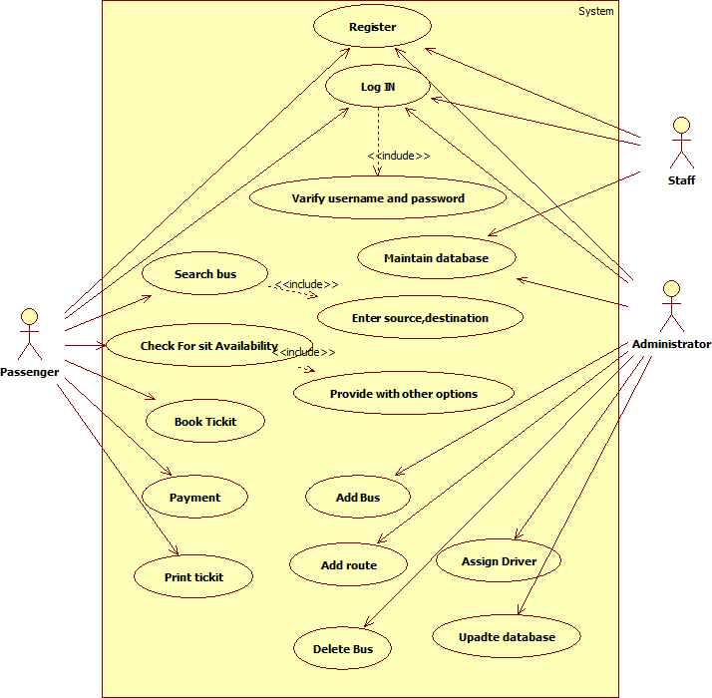

# Other Non-functional Requirements

# Performance Requirements

* + - **Response Time:** The system shall give responses in 1 second after checking the patient’s information.
    - **Capacity:** The System must support 1000 people at a time.
    - **User-interface:** The user-interface screen shall respond within 5 seconds.
    - **Conformity**: The systems must conform to the Microsoft Accessibility guidelines.
    - **Network Connection**: The system should be connected to internet 24x7 and the Server must on all time.

# Safety and Security Requirements

* + - **Passenger Identification:** The system requires the passenger to identify himself

/herself using PIN

* + - **Logon ID:** Any user who uses the system shall have a Logon ID and Password.
    - **Modification:** Any modification (insert, delete and update) for the Database shall be synchronized and done only by the administrator in the ward.
    - **Front Desk staff Rights**: Front Desk staff shall be able to view all information in BRS, add new buses to BRS but shall not be able to modify any information in it.
    - **Administrators**' **Rights**: Administrators shall be able to view and modify all information in BRS.

.

# Software Quality Attributes

#### Maintainability:

* + - * **Back-up:** The system shall provide the capability to back-up the Data
      * **Errors**: The system shall keep a log of all the errors.

#### Reliability:

* + - * **Availability:** The system shall be available all the time

# Appendix A – Data Dictionary

This SRS document is used to give details regarding Bus reservation System. In this all the - functional and non-functional requirements are specified in order to get a clear - cut idea to develop a project.

# Appendix B - Group Log

**Day-1:** *Date: -* 15-04-2021

A group of three people was made to prepare the project for Software Engineering. A sub topic was decided upon as **Bus Reservation System**. The topic and the group members’ names were then given to the Instructor. All the three members then read the example srs document provided and searched for the requisite document for system. The Problem description, the purpose and the scope of the document was finalized.

**Day-2:** *Date: -* 22-04-2021

Each section was divided among the three members and each member was given the task to complete their sections with proper theory. The entire document was then clubbed to form the SRS for **Bus Reservation System.**